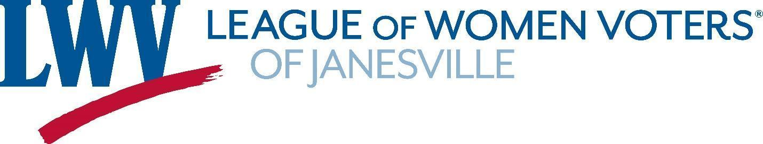

**Membership Form 2023-2024**

**Please fill out this form to ensure our contact information for you is up-to-date.**

**CONTACT INFORMATION**

Name _________________________________________________ Cell Phone No. ___________________________________

Address _________________________________________________ City______________________ State ____ Zip _________

Email ___________________________________________

**MEMBERSHIP CATEGORIES:**

**You may choose to pay dues by check or online with Paypal at** <https://www.lwvjvl.org/join-the-league>**.**

**Make checks payable to the LWV-Janesville, PO Box 8064, Janesville, WI 53547-8064.**

**(Our League membership year runs July 1-June 30.)**

|  |  |
| --- | --- |
| **$65 Active Membership** | For each Active Member, our League is assessed $32 National dues and $30 State dues. $3 remains in Janesville. |
| **$70 Supporting Membership** | Supporting Members are not called upon to serve on committees or working groups. |
| **$100 Active Household Membership** | Our League is assessed $16 (National) and $15 (State) for an additional person within a Household. |
| **$ ____ Open Door Membership** | Members pays dues they are comfortable with. Our League is not assessed State dues for members in this category. |
| **$10 Student Membership** | No National or State dues for high school and post-secondary students |

**For Household Membership:**

Name of additional member ___________________________________________________________________

Email ______________________________________________________ Phone # ________________________

If you wish to make a donation to support the LWV-JVL, please indicate the amount and include in your check:

**Dues: _____________ + Donation: _____________ = Total Amount Due: ______________**

**INTEREST AREAS:**

**Dues are important, but your involvement in the League’s work is what makes us a vital community organization. You can indicate which League activities are of greatest interest to you below. THANK YOU!**

|  |  |  |
| --- | --- | --- |
| Voter Education & Services | Diversity, Equity and Inclusion (DEI) | Sustainability |
| Observer Corps (monitor local government committees) | Fair Maps (non-partisan redistricting process) | Membership |
| Publicity and Social Media (includes newsletter and web page) | Janesville/Beloit Leagues Annual “Forward Together” Event | Other |

**If you selected “Other" and/or would like to say more about your interests in League activities, please tell us about them:**